|  |
| --- |
|  |
| **Travels and Tours Management System** |
| **Project Management Information System (PMIS)** |



**Software Group (1)**

Batch – ENU (1)

Prepared by

Mr. Myint Myat Kaung

Mr. Kaung Khant Zin

Ms. Yin Myat Thwe

Ms. Shune Lae Wutt Yee

Ms. Htet Yadanar Oo

Table of Contents

1. Travels and Tours Management System Project 2

1.1 Project Summary 3

1.2 Business Case 4

1.3 Configuration Map 5

1.4 Project Schedule Model 6

1.5 RIC register 8

1.6 Client Approval Confirmation 9

Travels and Tours Management System

1. Travels and Tours Management System Project

Travels and Tours Management System is a web-based application which include front-end website and back-end dashboard. The front-end website is for the customers of the travel agency which can call our client and the back-end dashboard for the travel agency company. This project is focused on viewing of tour package detail and ticket booking.

Our project management is going to base on the “P3.express” methodology for project preparing, planning, progress tracking, rick management and so on. We divided our project into 3 phases such as Start-up, Development and Closure. The project timeline is described below.

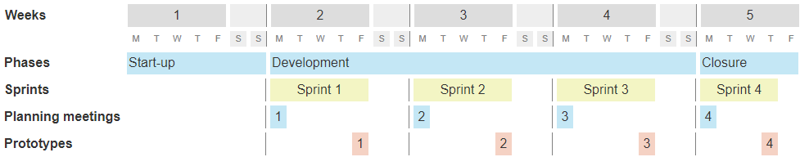

Figure : Project Timeline

We are going to use PHP programming language with Laravel framework to develop Travels and Tours Management System web application. Therefore, we need to install the following software to make the PHP development environment.

1. XAMPP
2. Composer
3. JetBrains (PhpStrom)

We will also use the following software and services to carry out the project management documentation.

1. Microsoft Offices 2016 (Word, PowerPoint, Excel, Project, Visio)
2. Click Chart
3. Google Drive
4. Github

1.1 Project Summary

To make project summary report, we used referenced from ‘P3.express’ project summary template form.

|  |  |  |  |  |  |  |
| --- | --- | --- | --- | --- | --- | --- |
| **Project Summary** | | | | | | |
| **Project Name** | | **Travels and Tours Management System** | | | | |
| **Dates** | | | | | | |
| **Sponsor Appointed** | | | **Project Authorized** | | | **Project Closed** |
| 20.8.2018 | | | 20.8.2018 | | | 20.9.2018 |
| **Purpose** | | | | | | |
| **Goal / Outcome**  The main goal of the project is to automate the process carried out in the travel services with improved performance and it will be made to more and developed work of art.  **Main Product**  Travels and Tours Management System (Web based application)  **High-level Requirements**  To convenient customers for viewing tour packages, tours booking, payment and searching tour packages by various categories. | | | | | | |
| **Targets** | | | | | | |
| **Duration** | | 5 weeks | | | | |
| **Budget** | | $ 6,000 | | | | |
| Major Risks | | | | | | |
| Project is very large with quick build-up, Unfamiliar with Laravel Framework, Inexperience in project management. | | | | | | |
| **Team Members and Roles** | | | | | | |
| **Dr. May Thu Aung** | | | **Mr. Myint Myat Kaung** | | | **Ms. Yin Myat Thwe** |
| Project Sponsor | | | Project Manager | | | Team Manager |
| **Mr. Kaung Khant Zin** | | | **Ms. Shune Lae Wutt Yee** | | | **Ms. Htet Yadanar Oo** |
| Team Manager | | | PM Support | | | PM Support |
| **Prepared by** | | | | **Approved by Project Sponsor** | | |
| (Sign) | | | | (Sign) | | |
| Name | Mr. Myint Myat Kaung | | | Name | Dr. May Thu Aung | |
| Date | 24.8.2018 | | | Date | 24.8.2018 | |

# 1.2 Business Case

We also used as referenced from “P3.express” business case template because this template is simple and have only main points for the project management. Less of fact to fill can cover our project startup times.

|  |  |
| --- | --- |
| **Business Case** | |
| **Project Name** | **Travels and Tours Management System** |
| **Business Purpose for doing the project** | |
| * To improve the experience of project management skills. To get knowledge and system development skills and experiences of Travels and Tours workflows/ processes. | |
| **Expected Benefits** | |
| * Project’s outcomes will improve the clients’ satisfaction. * Increased clients’ retention. * Greater client loyalty. * The clients will get increased collaboration. * Improved project team culture. * Increased revenue. | |
| **Expected Dis-Benefits** | |
| * Many kinds of risks can face during system developing. * Poor for solving risk management due to short period of the project. | |
| **Expected Cost** | |
| * Project Management = $ 1,400 * Project Team of 4 for 5 weeks = $ 3,200 * License Software = $ 500 * Material Resources = $ 900 * Total expected cost = $ 6,000 | |
| **Major Risk** | |
| * Very short time for system development. Therefore, some of the less prioritized function may not finished completely. | |

# 1.3 Configuration Map

We categorized three parts in Travels and Tours management system project. There are Administration, Management and Technology. These three parts include the consideration of organizing and managing the project team and technical things that we will use for the project development.

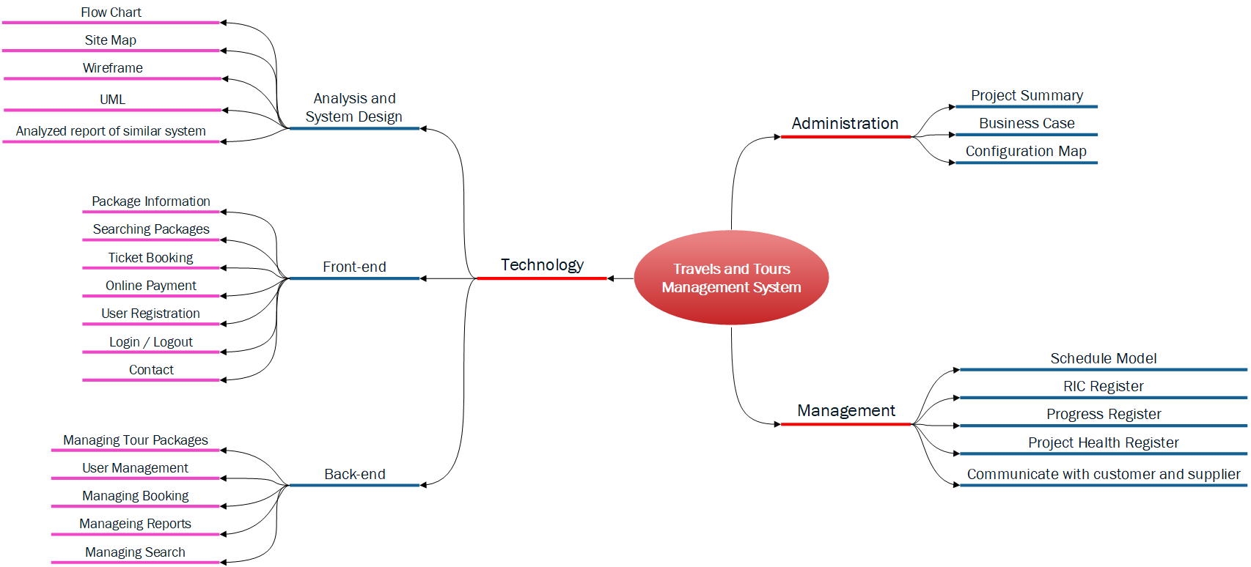

Figure : Configuration Map

# 1.4 Project Schedule Model

The below figures are to describe general information of project schedule. The detail tasks of project schedule will describe at Planning Meetings.

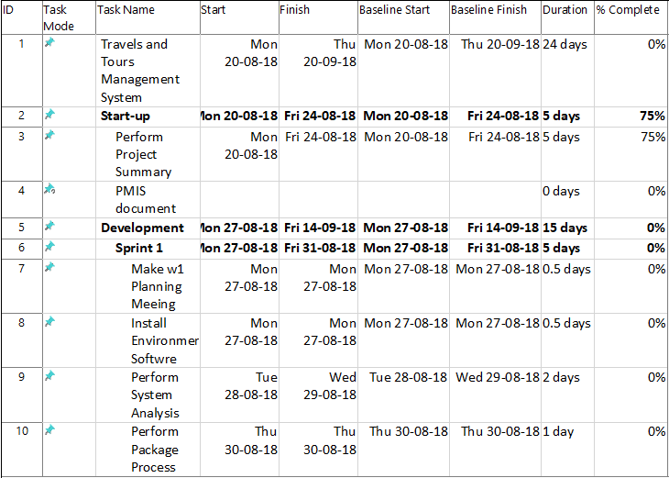

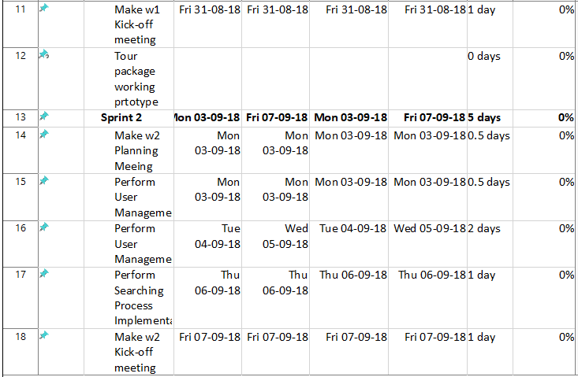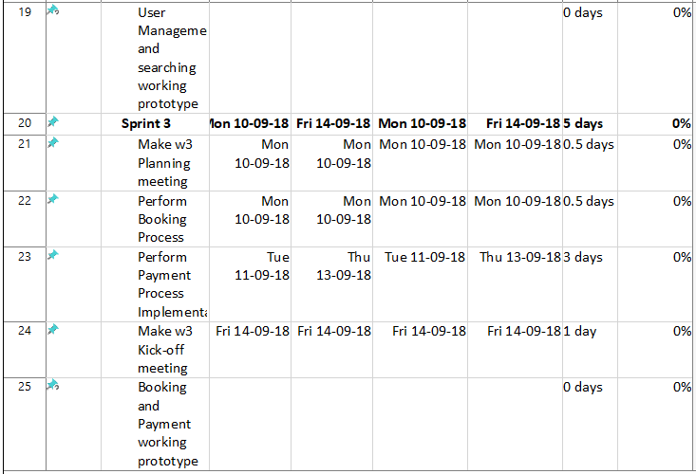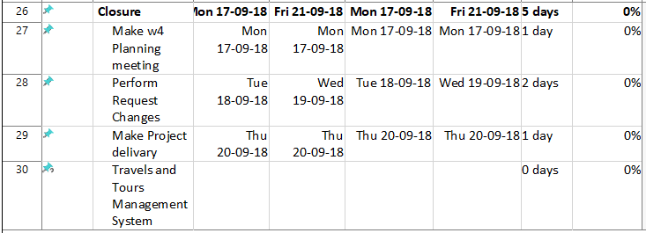

Figure : Schedule Model

# 1.5 RIC register

The following is the snapshot of RIC register. We also provide with Excel attached file.

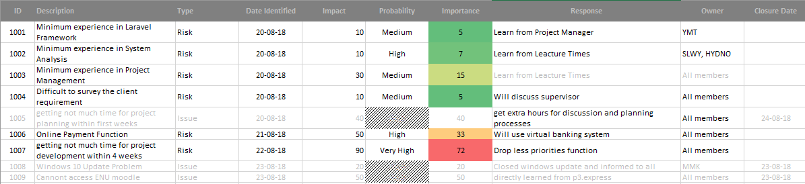

Figure : RIC Register

# 1.6 Client Approval Confirmation

**Signature Approvals**

We approve this information of the “Travels and Tours Management System” project including Tours package information, online booking and payment system, user management process and search tour package which is successfully implement according to project timeline.

|  |  |  |
| --- | --- | --- |
| Prepared by | Signature | Date |
| Myint Myat Kaung  Project Manager |  | 24.8.2018 |

|  |  |  |
| --- | --- | --- |
| Approved by | Signature | Date |
| [Name]  [Title]  [Organization] |  | 24.8.2018 |

|  |  |  |
| --- | --- | --- |
| Approved by | Signature | Date |
| [Name]  [Title]  [Organization] |  | 24.8.2018 |